TABLE OF CONTENTS
LIST OF FIGURES
LIST OF TABLES
CHAPTER 1. OVERVIEW
1.1. Introduction to Mining Massive Datasets
1.2. Introduction to the Topic
1.3. Problem Statement
1.4. Objectives and Scope
1.5. Methodology
1.6. Report Structure
CHAPTER 2. THEORETICAL BACKGROUND
2.1. Recommender Systems
2.2. Collaborative Filtering
2.3. Matrix Factorization
2.4. Implicit Feedback and ALS
2.5. Content-Based Recommendation
2.6. Ensemble Learning in Recommendation Systems
2.7. Evaluation Metrics
2.8. Large-Scale Data Processing in Recommendation Systems
CHAPTER 3. DATASETS AND DATA PROCESSING
3.1. Dataset Candidates
3.2. Amazon Reviews 2018 Dataset
3.3. Goodreads UCSD Book Graph Dataset
3.4. Reason for Changing from Amazon to Goodreads
3.5. Large-Scale Data Processing Pipeline
3.6. Exploratory Data Analysis
3.7. Processing Challenges and Solutions
CHAPTER 4. SYSTEM IMPLEMENTATION
4.1. Overall Development Strategy
4.2. Phase 1: Amazon Recommendation Pipeline
4.3. Phase 2: Goodreads Recommendation Pipeline
4.4. Edge Weighting Formulas
4.5. LDA-Based Taste Profile
4.6. ALS and Taste-Based Re-ranking
4.7. Phase 3: chainRec and Full-Ranking Evaluation
4.8. Web Demo
CHAPTER 5. RESULTS AND EVALUATION
5.1. Evaluation Protocol
5.2. Results on Amazon Reviews
5.3. Limitations Found from Amazon Experiments
5.4. Results on Goodreads
5.5. Edge Weighting Ablation Study
5.6. chainRec and Full-Ranking Evaluation
5.7. Discussion
CHAPTER 6. CONCLUSION AND FUTURE WORK
6.1. Conclusion
6.2. Limitations
6.3. Future Work
6.4. Work Allocation
REFERENCES
LIST OF FIGURES
Figure 3.1. Overall data processing pipeline
Figure 3.2. Goodreads rating distribution
Figure 3.3. Review volume over time
Figure 3.4. Review length by rating
Figure 3.5. Book and author popularity distribution
Figure 4.1. Overall recommendation pipeline
Figure 4.2. Amazon five-stage pipeline
Figure 4.3. Goodreads four-phase pipeline
Figure 5.1. Comparison of Amazon rating-prediction models
Figure 5.2. Amazon full-catalog ranking failure
Figure 5.3. Edge weighting ablation results on Goodreads
Figure 5.4. sampled@500 and full-ranking comparison
Figure 5.5. Web demo interface

LIST OF TABLES
Table 3.1. Comparison of candidate datasets
Table 3.2. Amazon dataset statistics after filtering
Table 3.3. Goodreads preprocessing steps
Table 4.1. Amazon pipeline stages
Table 4.2. Goodreads pipeline phases
Table 4.3. Edge weighting formulas
Table 5.1. Amazon Electronics results
Table 5.2. Home & Kitchen results
Table 5.3. Goodreads edge weighting ablation results
Table 5.4. chainRec sampled@500 results
Table 5.5. Full-ranking comparison between ALS and chainRec
Table 6.1. Work allocation
CHAPTER 1. OVERVIEW
1.1. Introduction to Mining Massive Datasets
Mining Massive Datasets is a field that focuses on extracting useful patterns, relationships, and knowledge from datasets that are too large, sparse, or complex to be processed using simple traditional methods. In many modern applications, data is generated continuously from user activities such as ratings, reviews, clicks, purchases, searches, comments, and interactions with online platforms.
In such settings, the main difficulty is not only building a machine learning model. A complete system must also be able to store data efficiently, process data in batches, handle missing and noisy values, avoid memory overflow, prevent data leakage, and evaluate the model under realistic conditions. Therefore, Mining Massive Datasets combines algorithmic knowledge with practical data engineering.
In this course project, our group selected the recommendation problem as the main application of Mining Massive Datasets. Recommender systems are widely used in e-commerce platforms, online bookstores, movie streaming services, music applications, and social networks. Their goal is to suggest items that are likely to match a user's interests based on previous user-item interactions.
The recommendation problem is highly suitable for this course because the data is usually very large and sparse. A user may interact with only a few items, while the full catalog may contain hundreds of thousands or even millions of items. This creates many practical challenges in data preprocessing, sparse matrix construction, model training, ranking evaluation, and scalability.
1.2. Introduction to the Topic
The topic of this project is to build and evaluate large-scale recommendation systems using two public datasets: Amazon Reviews 2018 and Goodreads UCSD Book Graph.
At the beginning of the project, Amazon Reviews 2018 was selected because it is a popular dataset in recommender system research and contains a large number of product reviews across different categories. The group implemented a complete recommendation pipeline on two Amazon categories: Electronics and Home & Kitchen. The purpose of this phase was to understand how classical recommendation methods perform on real e-commerce data.
However, after implementing rating prediction and ranking evaluation, the group found that good RMSE or MAE values did not necessarily lead to good recommendation quality. In particular, when the model was asked to recommend items from the full catalog, the ranking metrics were extremely low and the catalog coverage was also very limited. This showed that the model was mainly recommending popular items and was not able to discover relevant long-tail items.
For that reason, the project was extended to the Goodreads UCSD Book Graph dataset. Goodreads provides richer signals than Amazon, including ratings, review text, votes, shelves, genres, authors, and book metadata. More importantly, Goodreads naturally contains a behavior chain: a user may shelve a book, read it, rate it, and finally recommend it. This makes the dataset suitable for studying both traditional recommendation and behavior-chain recommendation.
Therefore, the project gradually developed through three phases: the Amazon recommendation pipeline, the Goodreads recommendation pipeline, and the chainRec/full-ranking evaluation extension.
1.3. Problem Statement
This project is built around four main questions.
First, how can a recommendation system be built on large-scale user-item interaction data while avoiding memory overflow and data leakage?
Second, does a large dataset always lead to a good recommender system, or do the characteristics of the dataset strongly affect the final recommendation quality?
Third, can additional signals such as review length, votes, genres, and behavior stages improve recommendation performance compared with using only rating values?
Fourth, are common evaluation protocols such as sampled ranking reliable enough, or is full-catalog ranking necessary to understand the real performance of a recommender system?
Through these questions, the project does not only aim to obtain a high metric value. More importantly, it aims to understand the complete process of building a recommender system on massive datasets, including preprocessing, modeling, evaluation, failure analysis, and improvement.
1.4. Objectives and Scope
The objectives of this project are as follows.
First, the group studies the basic theory of recommender systems, including collaborative filtering, matrix factorization, implicit feedback, ALS, content-based recommendation, ensemble learning, and ranking metrics.
Second, the group implements a complete recommendation pipeline on Amazon Reviews 2018. This includes data cleaning, temporal splitting, baseline construction, feature engineering, model training, ensemble learning, and evaluation.
Third, after identifying the limitations of the Amazon experiments, the group builds a new pipeline on Goodreads UCSD Book Graph. The Goodreads pipeline focuses more on large-scale preprocessing, edge-weighting formulas, user taste profiles, ALS recommendation, and ranking evaluation.
Fourth, the group investigates whether engagement signals, especially review length and votes, can improve recommendation quality. Five edge-weighting formulas are compared in an ablation study.
Fifth, the group explores a chainRec-based extension to model the natural behavior chain in Goodreads, including shelve, read, rate, and recommend stages.
The scope of this project is limited to offline recommendation experiments. The project does not build a production-level recommendation system and does not deploy the model on a real commercial platform. In addition, although the methodology can be applied to Vietnamese platforms, the current experiments are conducted on public English-language datasets.
1.5. Methodology
The project was carried out in several main steps.
First, the group reviewed the theoretical background of recommender systems and selected suitable datasets for experimentation.
Second, the group implemented the first recommendation pipeline on Amazon Reviews 2018. The data was cleaned, filtered, split by time, and stored in efficient formats. Several models were trained and compared, including baseline methods, item-item collaborative filtering, matrix factorization, content-based models, ALS, and ensemble models.
Third, the group evaluated the Amazon models using both rating prediction metrics and ranking metrics. This step revealed that RMSE and MAE were not sufficient to evaluate real recommendation quality.
Fourth, the group moved to Goodreads UCSD Book Graph and designed a new data processing pipeline. The raw data was converted from JSON.gz to partitioned Parquet files, joined with book metadata, cleaned, filtered, and split by year.
Fifth, the group trained ALS-based recommendation models using different edge-weighting formulas. The purpose was to evaluate whether rating, review length, votes, or their combinations provided better learning signals.
Sixth, the group extended the system with LDA-based taste profiles and chainRec experiments to better model book preference and multi-stage user behavior.
Finally, the group analyzed the results, discussed the limitations, and summarized the lessons learned from both successful and unsuccessful experiments.
1.6. Report Structure
The rest of this report is organized as follows.
Chapter 2 presents the theoretical background of recommender systems and large-scale recommendation. Chapter 3 describes the datasets, data preprocessing steps, exploratory data analysis, and large-scale processing challenges. Chapter 4 presents the implementation of the Amazon pipeline, Goodreads pipeline, edge-weighting methods, ALS models, chainRec extension, and demo system. Chapter 5 reports the experimental results and discusses the main findings. Chapter 6 concludes the project, summarizes the limitations, proposes future work, and presents the work allocation among group members.

CHAPTER 2. THEORETICAL BACKGROUND
2.1. Recommender Systems
A recommender system is a system that predicts which items a user may prefer and suggests those items to the user. The items can be products, books, movies, songs, courses, news articles, or any other objects that users can interact with.
In general, recommendation problems are based on historical user-item interactions. These interactions may be explicit or implicit. Explicit feedback includes ratings, reviews, likes, and scores given directly by users. Implicit feedback includes clicks, views, purchases, reading history, listening history, and other actions that indirectly indicate user preference.
There are two common tasks in recommendation systems. The first task is rating prediction, where the system predicts the numerical rating a user may give to an item. The second task is top-K recommendation, where the system ranks a large set of candidate items and returns the top K items for each user.
In practical recommendation systems, top-K recommendation is usually more important because users do not need a predicted rating for every item. They need a short list of items that are likely to be useful or interesting.
2.2. Collaborative Filtering
Collaborative filtering is one of the most widely used approaches in recommendation systems. The main idea is that users with similar behaviors may have similar preferences, and items liked by similar users can be recommended to a target user.
Collaborative filtering can be divided into two main types: memory-based methods and model-based methods.
Memory-based collaborative filtering directly uses the user-item interaction matrix. User-based collaborative filtering finds users similar to the target user and recommends items liked by those users. Item-based collaborative filtering finds items similar to the items that the target user has already interacted with.
Model-based collaborative filtering learns latent representations of users and items. Matrix factorization is a typical example of this approach.
In this project, item-item collaborative filtering was used in the Amazon phase as one of the auxiliary models. However, because the Amazon dataset is extremely sparse, many item pairs do not have enough common users. Therefore, the model often had to fall back to the baseline prediction.
2.3. Matrix Factorization
Matrix factorization is a popular model-based collaborative filtering method. It assumes that user preferences and item characteristics can be represented in a lower-dimensional latent space.
Given a user-item rating matrix, matrix factorization decomposes it into two smaller matrices: a user latent factor matrix and an item latent factor matrix. The predicted rating is computed as the dot product between the user vector and the item vector.
In this project, matrix factorization with stochastic gradient descent was used in the Amazon phase. Instead of directly modeling the raw rating, the model learned the residual between the actual rating and the baseline prediction. This helped the model focus on personalized deviations from the global or user-level average.
To speed up training, the implementation used Numba JIT compilation. This optimization was important because the original Python implementation was too slow for millions of interactions.
2.4. Implicit Feedback and ALS
Alternating Least Squares, or ALS, is a matrix factorization method commonly used for implicit feedback recommendation. In implicit feedback settings, the interaction does not directly tell whether a user likes an item. For example, a user may click on a product or add a book to a shelf, but the action is not always equivalent to a high rating.
ALS handles this by assigning confidence values to observed interactions. The model then alternates between fixing user factors and optimizing item factors, and fixing item factors and optimizing user factors.
In this project, ALS was used in both Amazon and Goodreads experiments. On Goodreads, ALS became one of the most important models because it could learn from large-scale user-book interaction data and worked well with edge weights.
2.5. Content-Based Recommendation
Content-based recommendation uses item features to recommend items similar to those that a user has liked before. In the context of books, content features may include title, author, genre, publication year, number of pages, and review topics. In the context of products, content features may include category, brand, product description, and review text.
In this project, content-based signals were used in two ways. In the Amazon phase, item profiles and user profiles were created and used as one of the auxiliary models. In the Goodreads phase, LDA was used to extract topic distributions from review text. These topic vectors were combined with genre affinity to build user taste profiles.
Content-based signals are especially useful when collaborative signals are sparse. However, they also have limitations. If the text or metadata is noisy, incomplete, or weakly connected to user preference, the content-based model may not improve recommendation quality.
2.6. Ensemble Learning in Recommendation Systems
Ensemble learning combines multiple models to obtain a better final prediction. In recommendation systems, different models may capture different signals. For example, matrix factorization captures latent collaborative structure, item-item collaborative filtering captures local item similarity, content-based models capture item features, and ALS captures implicit interaction patterns.
In the Amazon phase, the group tested multiple ensemble candidates, including manual blends, grid blends, residual blends, Ridge-positive ensembles, ElasticNet, HistGradientBoosting, and group-aware Ridge. The purpose was to determine whether combining different models could improve performance compared with individual models.
The experiments showed that ensemble learning could improve rating prediction metrics, but a more complex model did not always generalize better. In some cases, a simple Ridge-positive ensemble performed better on the test set than a more complex validation winner.
2.7. Evaluation Metrics
Evaluation is an important part of recommendation systems. In this project, two groups of metrics were used: rating prediction metrics and ranking metrics.
RMSE and MAE are used for rating prediction. RMSE gives higher penalty to large errors, while MAE measures the average absolute error. These metrics are useful when the goal is to predict rating values.
However, RMSE and MAE do not directly measure whether the system recommends useful items. Therefore, ranking metrics are also necessary. The main ranking metrics used in this project include Precision@K, Recall@K, NDCG@K, Hit@K, AUC, and catalog coverage.
Recall@K measures how many relevant items appear in the top K recommendations. NDCG@K also considers the position of relevant items in the ranked list. AUC measures whether positive items are ranked higher than negative items. Catalog coverage measures how many unique items are recommended by the system.
One important lesson from this project is that a model can have acceptable RMSE but still fail in full-catalog recommendation. Therefore, ranking metrics are more suitable for evaluating real recommendation quality.
2.8. Large-Scale Data Processing in Recommendation Systems
Large-scale recommendation systems require careful data processing. Raw datasets often contain duplicate records, invalid values, missing text, inconsistent timestamps, noisy reviews, and extremely imbalanced user-item distributions.
In this project, large-scale processing was especially important. The Amazon data contained millions of reviews per category, while Goodreads contained large JSON.gz files with reviews, interactions, book metadata, and author information. Processing these files required chunking, Parquet conversion, memory management, and partitioning by genre.
Another important issue is data leakage. In recommendation tasks, the model should predict future behavior based on past behavior. Therefore, the project used temporal splits instead of random splits. This made the evaluation more realistic.

CHAPTER 3. DATASETS AND DATA PROCESSING
3.1. Dataset Candidates
At the beginning of the project, several public recommendation datasets were considered, including MovieLens, Yelp, Last.fm, Amazon Reviews, and Goodreads.
MovieLens is clean and widely used, but it is relatively small and highly curated. It is useful for learning recommendation algorithms, but it does not fully represent large-scale data processing challenges.
Yelp contains reviews, ratings, business metadata, and location information. However, the business-review domain is less suitable for behavior-chain modeling.
Last.fm contains music listening behavior and is useful for implicit recommendation, but it does not provide rich textual review data and multi-stage behavior structure.
Amazon Reviews 2018 is very large and widely used in recommender-system research. It contains product reviews across many categories and is suitable for building a large-scale recommendation pipeline.
Goodreads UCSD Book Graph contains ratings, reviews, shelves, votes, comments, genres, authors, and book metadata. It also has a natural behavior chain in the book domain. For this reason, Goodreads was selected after the limitations of Amazon became clear.
Table 3.1. Comparison of candidate datasets
Dataset | Advantages | Limitations | Decision
MovieLens | Clean, easy to use, common benchmark | Smaller scale, less data engineering challenge | Not selected
Yelp | Reviews and business metadata | Less suitable for behavior-chain modeling | Not selected
Last.fm | Useful implicit music interactions | Limited textual and review signals | Not selected
Amazon Reviews 2018 | Very large, many categories, common RecSys dataset | Heavy long-tail and popularity bias | Used in Phase 1
Goodreads UCSD Book Graph | Reviews, votes, shelves, genres, behavior chain | Large and harder to preprocess | Used in Phase 2 and Phase 3
3.2. Amazon Reviews 2018 Dataset
Amazon Reviews 2018 is a large-scale dataset containing product reviews across many product categories. In this project, the group used two categories: Electronics and Home & Kitchen.
These two categories were selected because they represent two different product domains and both contain millions of reviews. Electronics contains many technical products with strong item diversity, while Home & Kitchen contains everyday household products with different user behavior patterns.
After k-core filtering, the Electronics category contained more than 5.5 million reviews, around 609 thousand users, and 145 thousand items. Home & Kitchen contained more than 5.6 million reviews, around 647 thousand users, and 170 thousand items. Both categories had extremely high sparsity, above 99.99%.
Table 3.2. Amazon dataset statistics after filtering
Category | Original Reviews | Reviews after 5-core | Users | Items | Sparsity
Electronics | ≈14M | 5,517,640 | 609K | 145K | 99.99%
Home & Kitchen | 13,824,810 | 5,622,812 | 647K | 170K | 99.9949%
The raw Amazon data was cleaned through seven main steps: removing HTML and emoji, normalizing Unicode, parsing and validating timestamps, dropping reviews with rating equal to zero or empty text, deduplicating reviews by user, item, and timestamp, filtering very short reviews, and filtering extremely long reviews.
The cleaned data was saved in compressed partitioned Parquet format. Each category was loaded separately to avoid memory overflow in the Kaggle environment.
3.3. Goodreads UCSD Book Graph Dataset
Goodreads UCSD Book Graph is a large-scale dataset collected from Goodreads. It contains the social and behavioral structure of the platform, including ratings, reviews, shelves, votes, comments, book metadata, authors, and genres.
The raw dataset contains several JSON.gz files with a total size of approximately 16GB. It covers ten genres: children, comics, fantasy, fiction, history, mystery, non-fiction, poetry, romance, and young-adult.
The dataset is suitable for this project because it provides richer signals than Amazon. In addition to ratings and review text, it also contains votes and shelves. These signals make it possible to study engagement-aware recommendation and behavior-chain recommendation.
Table 3.3. Goodreads preprocessing steps
Step | Description
1 | Download raw JSON.gz files for interactions, reviews, books, and authors
2 | Convert JSON.gz files into Parquet chunks
3 | Partition data by primary genre
4 | Upload intermediate files to HuggingFace for reuse
5 | Join reviews, interactions, and book metadata by book_id
6 | Cast rating and vote columns to numeric types
7 | Parse date_added into timestamp
8 | Remove invalid ratings and null review text
9 | Clean review text by removing HTML and normalizing whitespace
10 | Compute review length, vote weight, edge weight, and user statistics
11 | Split data by year: train ≤ 2015, validation = 2016, test = 2017
12 | Keep users with at least five training reviews
After preprocessing, the Goodreads pipeline used approximately 15.7 million reviews and ten genre partitions.
3.4. Reason for Changing from Amazon to Goodreads
The project did not move from Amazon to Goodreads arbitrarily. The decision was based on experimental results.
In the Amazon phase, the models achieved reasonable RMSE and MAE values. However, when the models were evaluated using full-catalog ranking, the results were almost zero. The catalog coverage at top-20 was only 1.56%, which means the model recommended only a very small portion of the full item catalog.
This showed that the model learned to predict ratings for observed user-item pairs, but it did not learn to discover new relevant items from the entire catalog. The main reason was the strong long-tail structure of the Amazon data. A small number of head items had many reviews, while most items had very few reviews. As a result, embeddings for tail items were weak and the model preferred popular items.
Goodreads was selected because its structure is more suitable for preference modeling. The rating distribution is more balanced, the users are more engaged, and the dataset contains richer signals such as review length, votes, shelves, genres, and behavior stages.
3.5. Large-Scale Data Processing Pipeline
Large-scale data processing was one of the most important parts of the project. The group did not simply train models on a small prepared CSV file. Instead, the project required processing raw or semi-processed large datasets, converting file formats, cleaning text, joining metadata, filtering users and items, and preparing temporal splits.
For Amazon, the main processing focus was cleaning review text, filtering invalid records, deduplication, k-core filtering, and saving the output as compressed Parquet files.
For Goodreads, the processing pipeline was more complex. The group converted JSON.gz files into Parquet format, processed files by chunks, partitioned data by genre, joined multiple data sources, computed user statistics, and created features such as review length and edge weights.
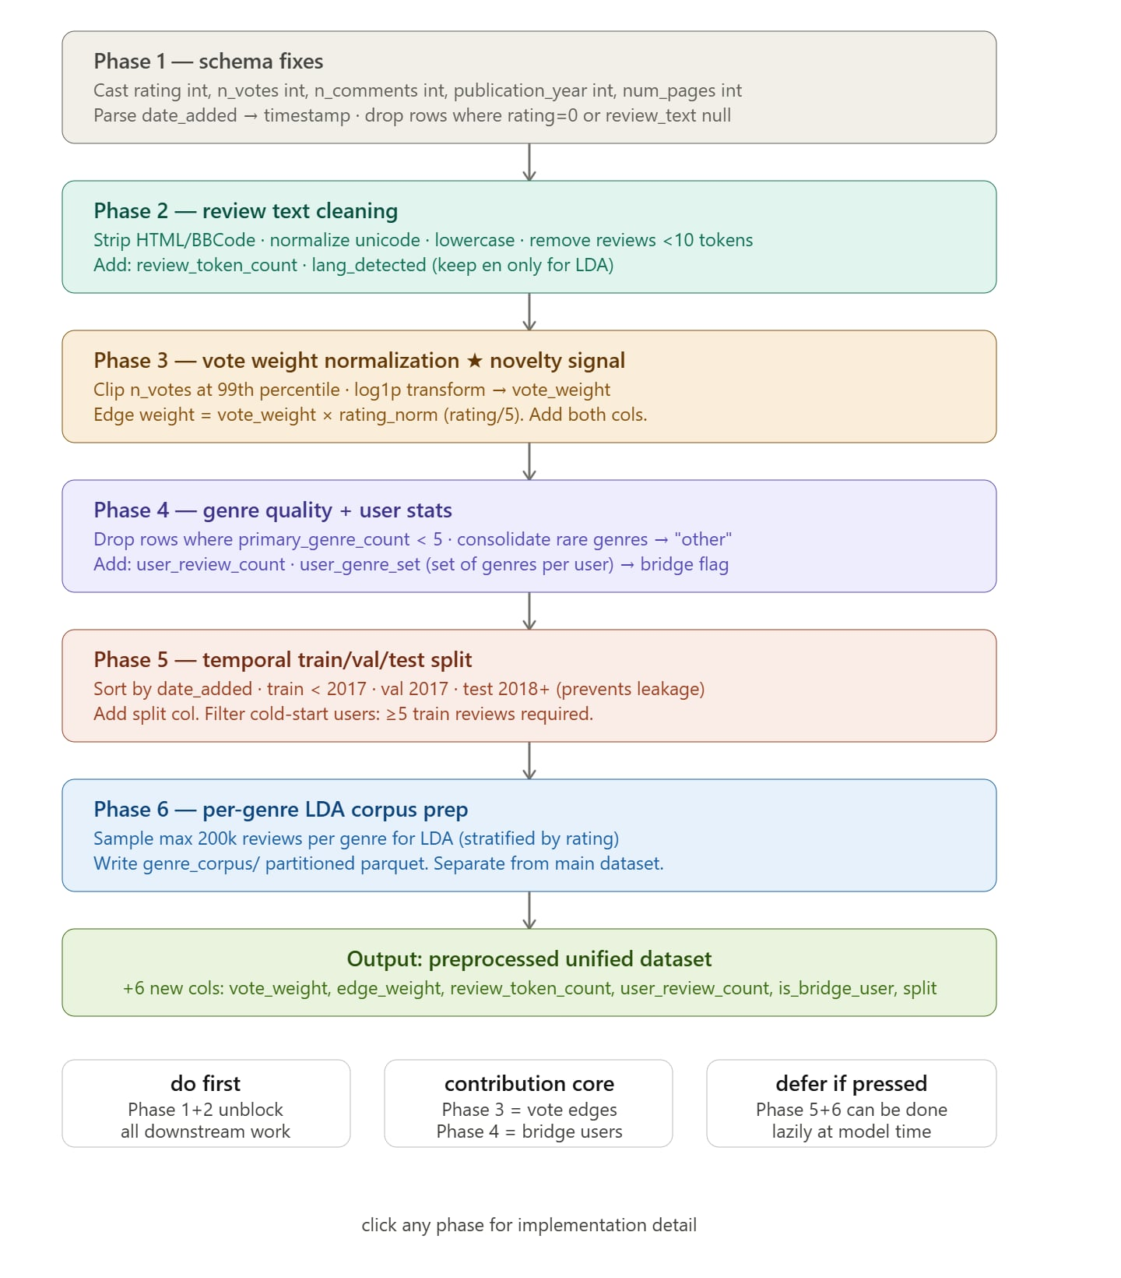
Figure 3.1. Overall data processing pipeline
3.6. Exploratory Data Analysis
Exploratory Data Analysis was performed to understand the characteristics of each dataset before model training.
On Amazon, the group observed that the rating distribution was highly imbalanced. In Home & Kitchen, 5-star reviews accounted for around 65.5% of all reviews, while 1-star and 2-star reviews were much less common. This caused models to be biased toward high ratings.
On Goodreads, the group observed a different pattern. Review length tended to increase with rating. In other words, users often wrote longer reviews when they liked a book. This suggested that review length could be used as an engagement signal.
The group also identified bridge users, who read books across three or more genres. These users are useful because they connect different genre communities and provide cross-genre preference information.
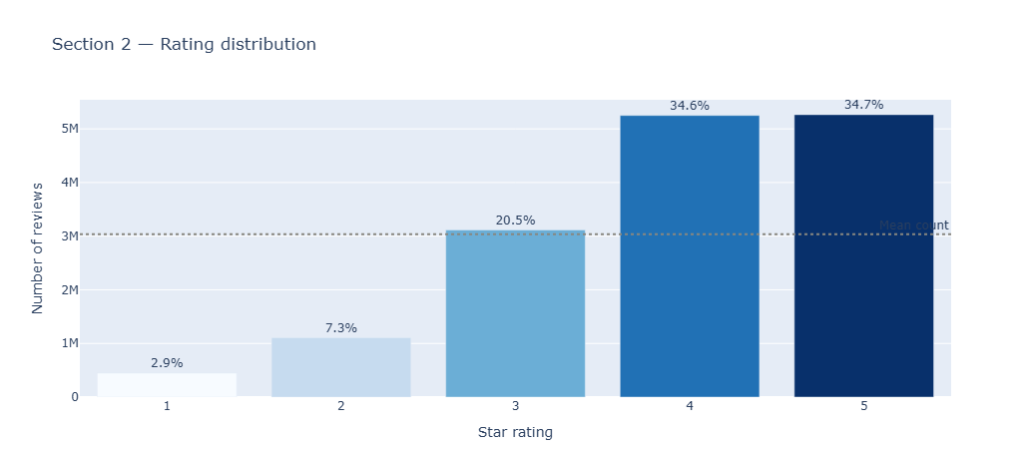
Figure 3.2. Goodreads rating distribution
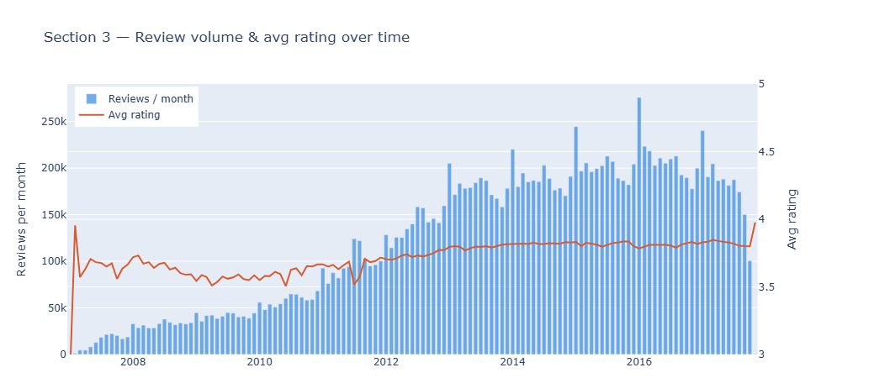
Figure 3.3. Review volume over time
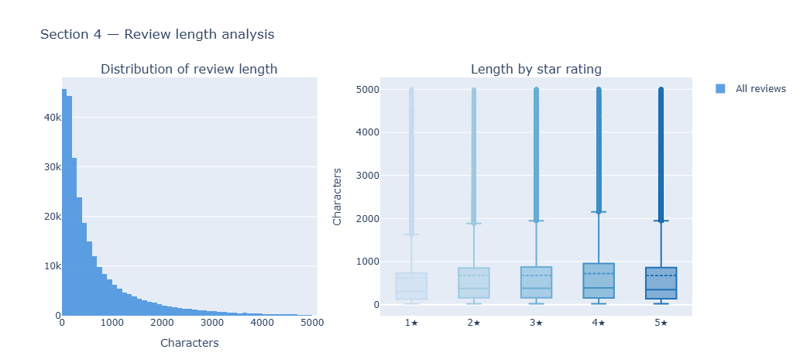
Figure 3.4. Review length by rating
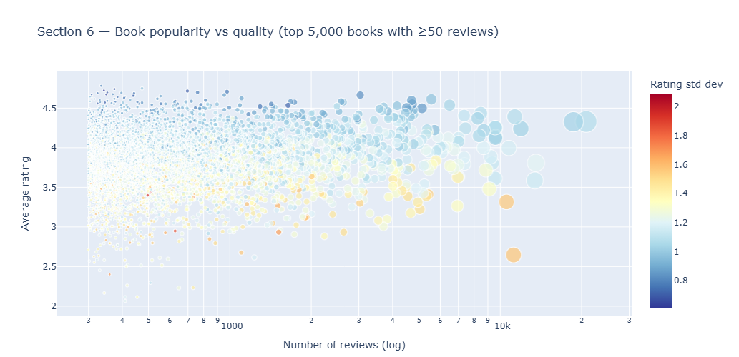
Figure 3.5. Book and author popularity distribution
3.7. Processing Challenges and Solutions
Several technical problems occurred during preprocessing.
First, loading the full Goodreads dataset into memory caused RAM overflow. This was solved by processing files incrementally and deleting temporary dataframes after each step.
Second, some genres, especially fantasy, were too large to load in one step. This was solved by using batch iteration with Parquet files instead of reading the entire file at once.
Third, user statistics were incorrect when computed separately by genre because the same user could appear in multiple genres. This was solved using a two-pass strategy. The first pass computed global user statistics, and the second pass processed each genre using those global values.
Fourth, the date format was inconsistent. Some fields used mixed date formats instead of a single ISO format. This was handled by using flexible timestamp parsing.
Fifth, HuggingFace file paths caused encoding problems when special characters appeared in partition names. This was solved by using the HuggingFace file system interface directly.
These problems show that the project involved real large-scale data processing challenges, not only model training.

CHAPTER 4. SYSTEM IMPLEMENTATION
4.1. Overall Development Strategy
The project was implemented in three phases.
Phase 1 focused on Amazon Reviews 2018. The goal was to build a complete recommendation pipeline using classical recommendation methods and ensemble learning.
Phase 2 focused on Goodreads UCSD Book Graph. The goal was to build a more suitable recommendation pipeline for book data and test whether engagement signals such as review length and votes could improve recommendation performance.
Phase 3 focused on chainRec and full-ranking evaluation. The goal was to evaluate behavior-chain modeling and test whether the positive findings from sampled evaluation remained valid under stricter full-catalog ranking.
✗
Figure 4.1. Overall recommendation pipeline [ cần thêm hình — insert chart here ]
4.2. Phase 1: Amazon Recommendation Pipeline
The Amazon pipeline was organized into five stages.
Table 4.1. Amazon pipeline stages
Stage | Role | Main Output
Stage 0 | Canonical data and baseline | train.parquet, test.parquet, Bayesian shrinkage baseline
Stage 1 | Cold-start profiling | User groups: new, cold, medium, warm
Stage 2 | Feature engineering | item profiles, user profiles, normalized matrix, implicit matrix
Stage 3 | Auxiliary models | Model A/B/C/D predictions
Stage 4 | Ensemble and meta-learning | 16 candidates, Ridge-positive winner
Stage 5 | Extended evaluation | RMSE, MAE, Precision@K, NDCG@K, Coverage
The pipeline followed an anti-leakage design. The data was split by time instead of randomly. All fitting and transformations were performed using training data only. Validation data was used for model selection, and test data was used only for final reporting.
The baseline model used Bayesian shrinkage. This helped prevent unstable predictions for users or items with very few interactions.
Four auxiliary models were implemented in Stage 3.
Model A was item-item collaborative filtering. It used cosine similarity between item vectors and fallback rules when there were not enough neighbors.
Model B was matrix factorization with SGD. It learned latent user and item vectors on the residual between the actual rating and the baseline prediction. Numba JIT was used to speed up training.
Model C was content-based recommendation. It used user and item profiles to compute similarity and adjust the baseline prediction.
Model D was implicit ALS. It learned from binary interaction data and confidence values.
Stage 4 tested several ensemble methods, including manual blends, grid blends, residual blends, Ridge-positive ensembles, ElasticNet, HistGradientBoosting, and group-aware Ridge.
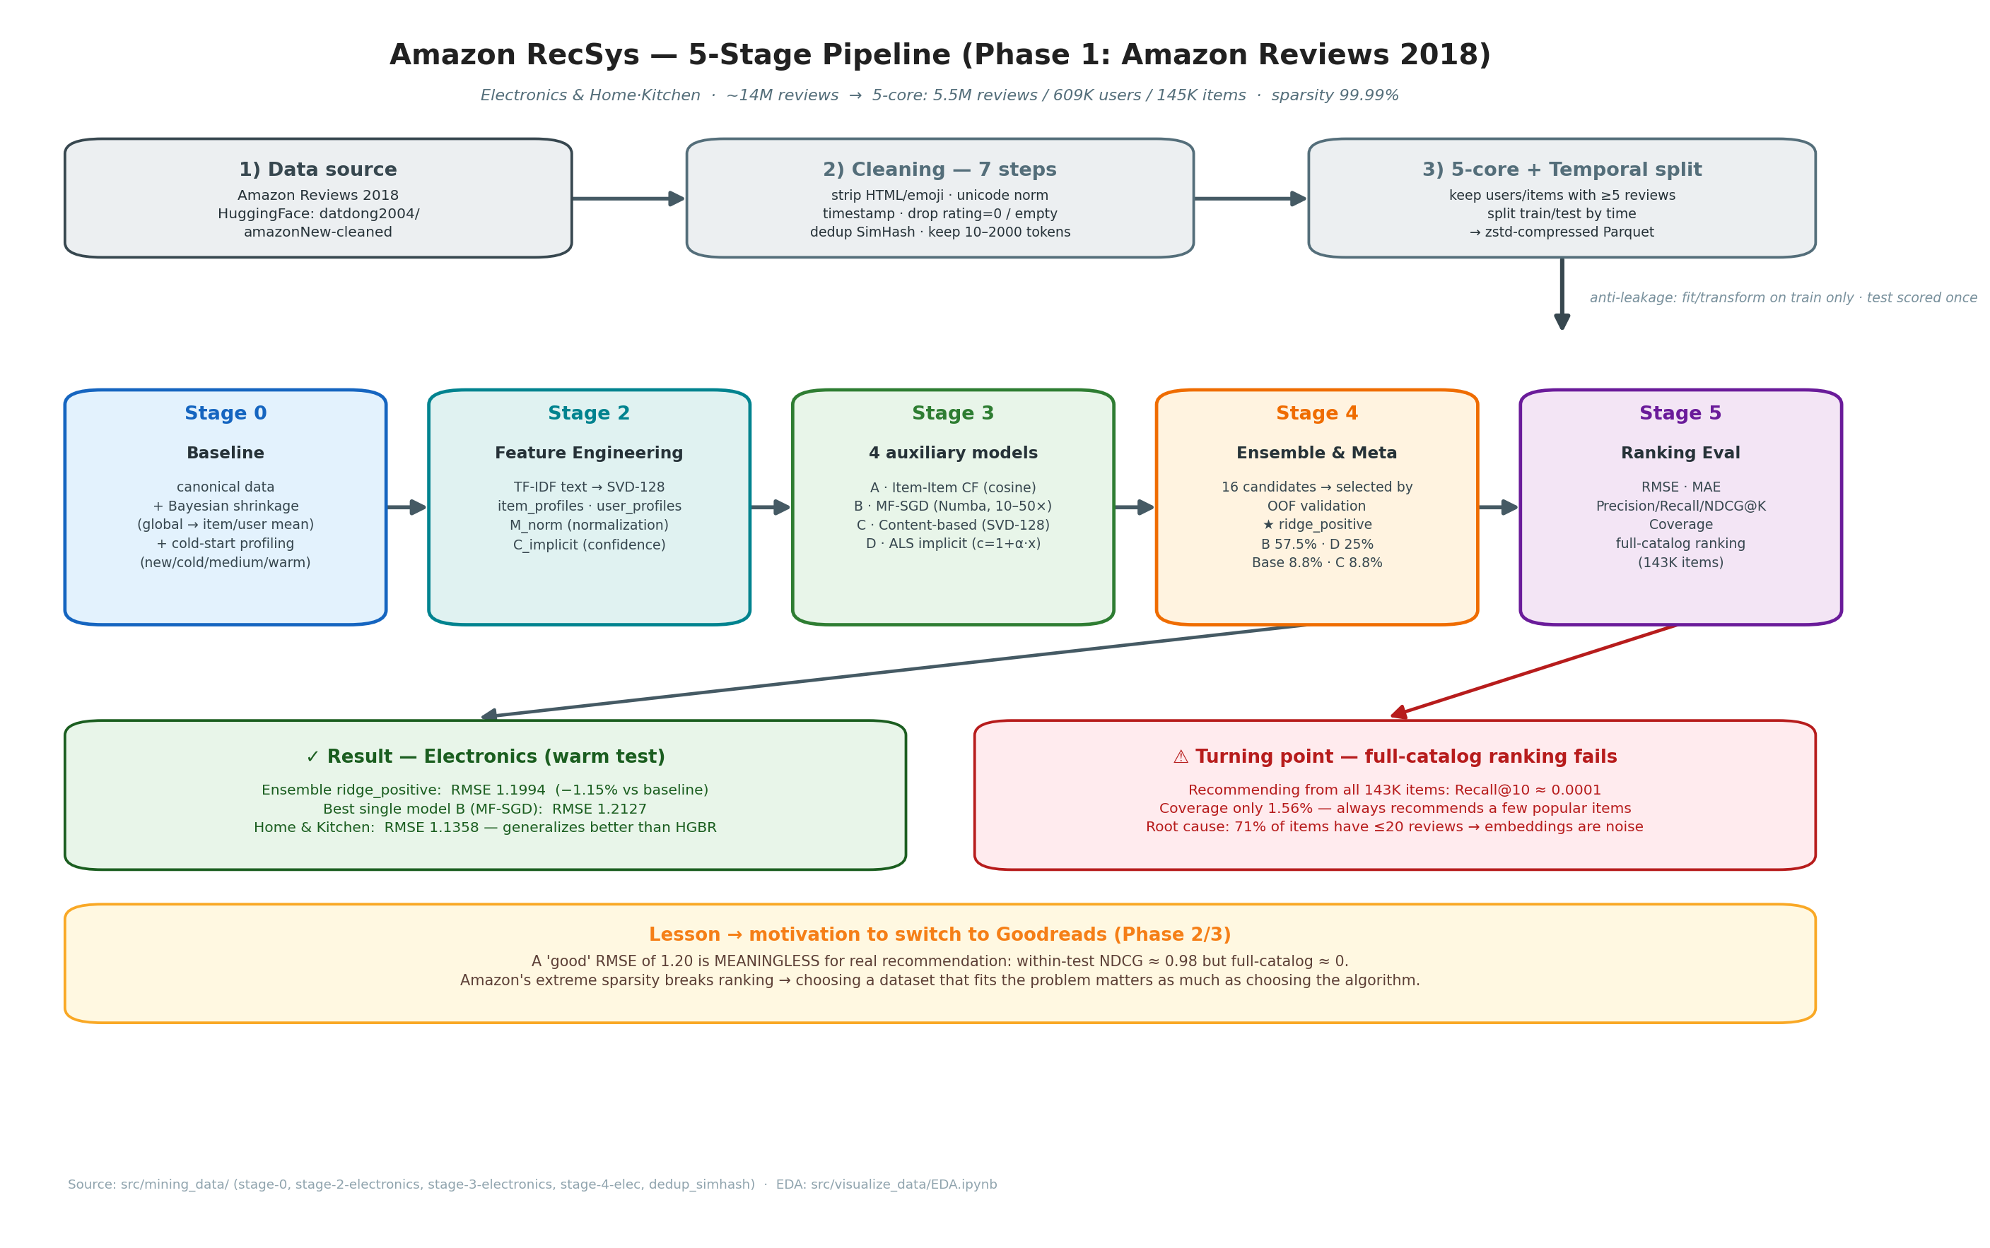
Figure 4.2. Amazon five-stage pipeline
4.3. Phase 2: Goodreads Recommendation Pipeline
The Goodreads pipeline was organized into four phases.
Table 4.2. Goodreads pipeline phases
Phase | Role | Main Output
Phase 1 | EDA and preprocessing | Cleaned Parquet files partitioned by genre
Phase 2 | Edge weighting ablation | Five ALS models using F1–F5 formulas
Phase 3 | LDA taste profile | 50-dimensional user taste profile
Phase 4 | ALS + taste blend + evaluation | Final recommendations and ranking metrics
The Goodreads pipeline was designed to use both collaborative signals and textual/content signals. ALS was used to generate candidate recommendations. Then, LDA-based taste profiles were used to re-rank these candidates.
This design allowed the system to combine collaborative filtering with user taste information extracted from review text and genre preferences.
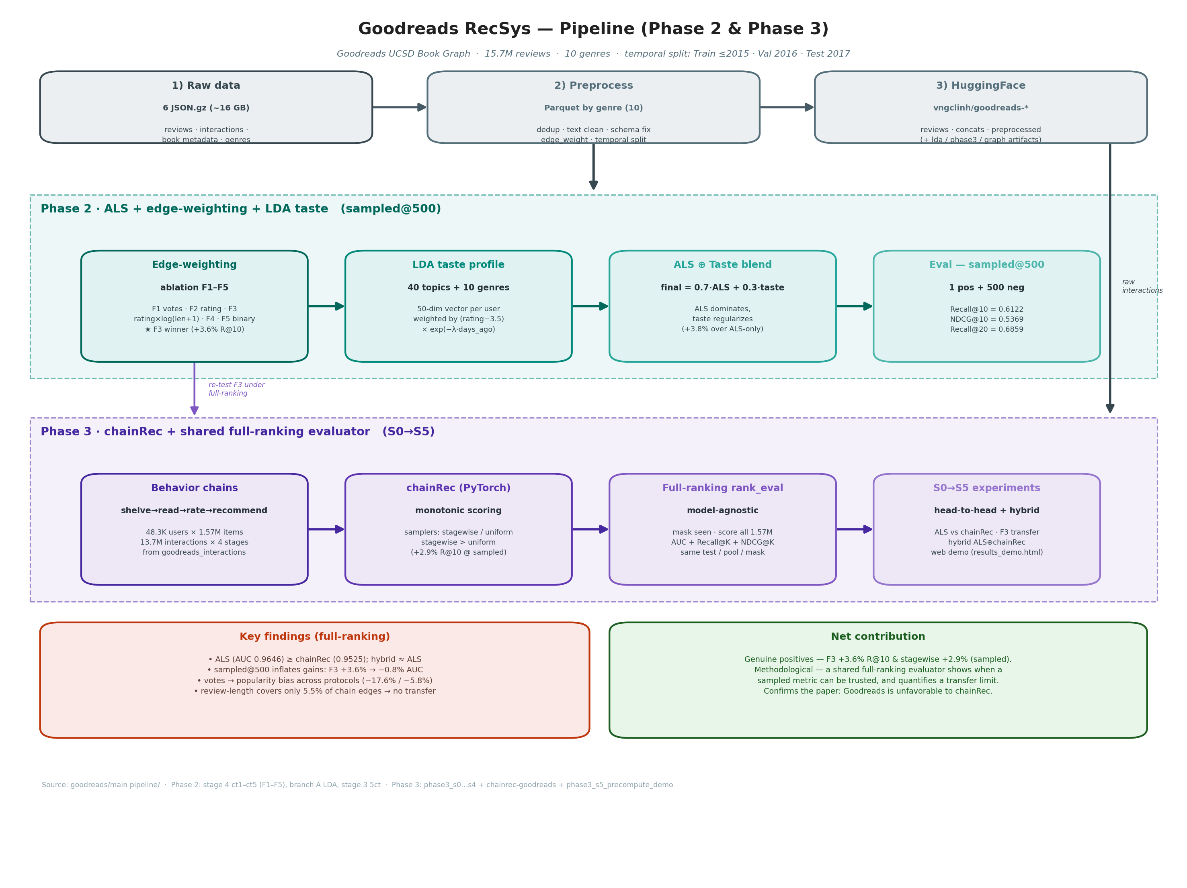
Figure 4.3. Goodreads four-phase pipeline
4.4. Edge Weighting Formulas
The main experiment in the Goodreads phase was the comparison of five edge-weighting formulas. The purpose was to test which signal should be used as the confidence value in the user-book interaction matrix.
Table 4.3. Edge weighting formulas
Formula | Name | Definition | Meaning
F1 | vote_weighted | rating × log(votes + 1) / 5 | Votes represent review helpfulness
F2 | rating_only | rating / 5 | Simple rating baseline
F3 | rating_length | rating × log(length + 1) / 5 | Longer review indicates higher engagement
F4 | combined | rating × log(votes + 1) × log(length + 1) | Combines rating, votes, and length
F5 | binary | 1 if rating ≥ 4 else 0 | Positive-only implicit feedback
The hypothesis was that review length and votes might provide additional engagement signals beyond rating values. However, the experiments showed that these signals behaved differently.
4.5. LDA-Based Taste Profile
To include textual information, the group used Latent Dirichlet Allocation, or LDA, to build topic distributions from review text. LDA was trained with 40 topics using sampled reviews from each genre.
Each user was represented by a 50-dimensional taste profile. The first 40 dimensions represented topic distribution, while the remaining 10 dimensions represented genre affinity.
The user taste profile was computed as a weighted average of book topic distributions. The weight depended on the user’s rating and the recency of the interaction.
This profile was used in the re-ranking step. After ALS generated candidate books, the system computed cosine similarity between the user taste profile and each candidate book profile.
4.6. ALS and Taste-Based Re-ranking
In the final Goodreads Phase 2 pipeline, ALS was used to generate the top candidate books for each user. Then, the candidates were re-ranked using a combination of ALS score and taste similarity.
The final score was computed as:
final_score = α × ALS_score + (1 − α) × taste_similarity
The value of α was tuned on the validation set. The best value was α = 0.7, meaning that the final score used 70% ALS collaborative signal and 30% taste similarity.
This result suggests that collaborative filtering remained the main signal, while the taste profile provided useful additional information.
4.7. Phase 3: chainRec and Full-Ranking Evaluation
In Phase 3, the group explored chainRec, a recommendation model designed for behavior chains. Goodreads naturally supports a sequence of user actions:
shelve → read → rate → recommend
The group implemented a chainRec data loader and model training pipeline. The data contained four behavior stages: shelve, read, rate, and recommend. The interaction distribution showed that many users shelved books, but only a small portion of shelved books were actually read.
The group also implemented a full-ranking evaluator. Unlike sampled@500 evaluation, full-ranking evaluation ranks items against the full catalog and masks items already seen by the user. This setting is much stricter and closer to real recommendation.
The purpose of Phase 3 was to test whether the positive findings from Phase 2 were still valid under full-ranking evaluation.
4.8. Web Demo
A simple web demo was built to visualize recommendation results. The demo renders a subset of books and recommendation outputs. It is useful for demonstration and inspection, but it does not replace quantitative evaluation.
Because the full Goodreads catalog is very large, the demo uses a subset of books for practical performance reasons. Therefore, it should be described as a demonstration interface rather than a production-level recommendation system.
✗
Figure 5.5. Web demo interface [ cần thêm hình — insert chart here ]

CHAPTER 5. RESULTS AND EVALUATION
5.1. Evaluation Protocol
The project used both rating prediction metrics and ranking metrics.
For rating prediction, RMSE and MAE were used. These metrics measure how close the predicted rating is to the actual rating.
For ranking evaluation, the project used Precision@K, Recall@K, NDCG@K, Hit@K, AUC, and catalog coverage. These metrics are more suitable for measuring the quality of top-K recommendation.
In Amazon Phase 1, both rating prediction and full-catalog ranking were evaluated. In Goodreads Phase 2, sampled@500 ranking evaluation was used for the edge-weighting ablation. In Phase 3, full-ranking evaluation was used to obtain a stricter and more realistic comparison.
5.2. Results on Amazon Reviews
On the Electronics category, the baseline achieved RMSE 1.21344 and MAE 0.92511. Model B, which used matrix factorization with SGD, was the best single model, with RMSE 1.21267 and MAE 0.86822.
The final Ridge-positive ensemble achieved RMSE 1.19943 and MAE 0.89474. This improved RMSE by approximately 1.15% compared with the baseline.
Table 5.1. Amazon Electronics results
Model | RMSE | MAE | Comment
Baseline | 1.21344 | 0.92511 | Reference
Model A: Item-CF | 1.21537 | 0.92490 | Worse than baseline, high fallback rate
Model B: MF-SGD | 1.21267 | 0.86822 | Best single model
Model C: Content-based | 1.21344 | 0.92511 | Similar to baseline
Model D: ALS | 1.21344 | 0.92480 | Small improvement
Ridge-positive ensemble | 1.19943 | 0.89474 | Best final rating result
On Home & Kitchen, Model B improved MAE but slightly increased RMSE. The final Ridge-positive ensemble performed better on the test set than the more complex HistGradientBoosting model. This showed that a validation winner is not always the best model on unseen test data.
Table 5.2. Home & Kitchen results
Model | RMSE | MAE | Comment
Baseline | 1.1442 | 0.8552 | Reference
Model A | 1.1442 | 0.8551 | Almost equal to baseline
Model B | 1.1493 | 0.8049 | Best MAE but worse RMSE
Model C | 1.1476 | 0.8859 | Better on low ratings
Model D | 1.1442 | 0.8551 | Weak ALS signal
Ridge-positive | 1.1358 | 0.8380 | Best generalization
✗
Figure 5.1. Comparison of Amazon rating-prediction models [ cần thêm hình — insert chart here ]
5.3. Limitations Found from Amazon Experiments
Although the rating-prediction results looked acceptable, the full-catalog ranking evaluation revealed a serious limitation.
For the Electronics category, when the model ranked items from the full catalog, Precision@K, Recall@K, NDCG@K, and Hit@K were almost zero. Catalog coverage at top-20 was only 1.56%.
This means that the model repeatedly recommended a small group of popular items and ignored most of the catalog. At the same time, within-test ranking was almost perfect. Therefore, the model could rank already-observed test items, but it could not discover truly relevant items from the full catalog.
This was the key reason for changing from Amazon to Goodreads. The problem was not only the algorithm, but also the structure of the Amazon dataset. The item distribution was too long-tailed, and most items had too few interactions to learn reliable embeddings.
✗
Figure 5.2. Amazon full-catalog ranking failure [ cần thêm hình — insert chart here ]
5.4. Results on Goodreads
On Goodreads, the main result of Phase 2 was the edge-weighting ablation study. The group trained ALS models using five different edge-weighting formulas and evaluated them using sampled@500 ranking.
The best formula was F3:
rating × log(length + 1) / 5
This formula uses review length as an engagement signal. It achieved Recall@10 = 0.6122 and NDCG@10 = 0.5369.
The rating-only baseline F2 achieved Recall@10 = 0.5757 and NDCG@10 = 0.5107. Therefore, F3 improved Recall@10 by approximately 3.6% compared with the rating-only baseline.
Table 5.3. Goodreads edge weighting ablation results
Variant | Recall@10 | NDCG@10 | Recall@20 | NDCG@20 | Compared with F2
F3: rating_length | 0.6122 | 0.5369 | 0.6859 | 0.5597 | +3.6%
F2: rating_only | 0.5757 | 0.5107 | 0.6447 | 0.5311 | Baseline
F5: binary | 0.5613 | 0.4995 | 0.6278 | 0.5189 | −2.5%
F1: vote_weighted | 0.4744 | 0.4217 | 0.5448 | 0.4419 | −17.6%
F4: combined | 0.4237 | 0.3752 | 0.4971 | 0.3961 | −26.4%
These results suggest that review length can be a useful engagement signal in Goodreads. Users who write longer reviews may have stronger opinions or deeper engagement with the books.
However, vote-based formulas performed poorly. F1 and F4 were much worse than the rating-only baseline. This suggests that votes introduce popularity bias. Popular books naturally receive more votes, but this does not mean they are better personalized recommendations for every user.
5.5. Edge Weighting Ablation Study
The ablation study produced two main observations.
First, review length was useful under sampled@500 evaluation. In Goodreads, longer reviews were often associated with stronger positive engagement. Therefore, F3 performed better than F2.
Second, votes were not reliable as personalization signals. Although votes may indicate that a review is helpful, they also correlate strongly with book popularity. When votes were used as edge weights, the model became more biased toward popular books and performed worse.
This result is important because social signals may look useful at first, but they can hurt personalization if they mainly represent popularity instead of individual preference.
✗
Figure 5.3. Edge weighting ablation results on Goodreads [ cần thêm hình — insert chart here ]
5.6. chainRec and Full-Ranking Evaluation
In Phase 3, the group evaluated chainRec and ALS under both sampled@500 and full-ranking protocols.
Under sampled@500 evaluation, chainRec with a stagewise sampler performed better than the uniform sampler. The stagewise sampler achieved Recall@10 = 0.7746 and NDCG@10 = 0.6193, while the uniform sampler achieved Recall@10 = 0.7530 and NDCG@10 = 0.5921.
Table 5.4. chainRec sampled@500 results
Sampler | AUC | Recall@10 | NDCG@10
Uniform | 0.9437 | 0.7530 | 0.5921
Stagewise | 0.9479 | 0.7746 | 0.6193
However, when the same models were evaluated using full-ranking, Recall@10 dropped sharply. This is expected because full-ranking requires the model to rank relevant items among more than one million candidate items, instead of only 500 random negative items.
The full-ranking comparison showed that plain ALS performed better than chainRec on Goodreads. ALS achieved AUC = 0.9646 and Recall@10 = 0.1588, while chainRec achieved Recall@10 around 0.05.
Table 5.5. Full-ranking comparison between ALS and chainRec
Model | AUC | Recall@10 | NDCG@10 | Recall@20
chainRec uniform | 0.9500 | 0.0506 | 0.0288 | 0.0774
chainRec stagewise | 0.9525 | 0.0500 | 0.0301 | 0.0674
ALS vanilla | 0.9646 | 0.1588 | 0.0988 | 0.2144
item popularity | 0.2918 | 0.0032 | 0.0016 | —
The group also tested whether F3 review-length weighting could improve chainRec. The result was negative. F3 did not transfer well to chainRec because review-length information covered only a small part of the interaction graph. Therefore, the review signal and the chain-interaction signal were weakly overlapping.
Another important result was that F3 did not remain clearly beneficial under full-ranking evaluation, even when applied to review-based ALS. This suggests that the positive Phase 2 result was partly influenced by the sampled@500 evaluation protocol.
The group also tested hybrid ALS and chainRec score fusion. The hybrid model performed similarly to ALS but did not significantly outperform it. This means that, under the current setup, chainRec did not add enough useful information beyond ALS.
✗
Figure 5.4. sampled@500 and full-ranking comparison [ cần thêm hình — insert chart here ]
5.7. Discussion
The project produced several important lessons.
First, a large dataset does not automatically produce a good recommender system. Amazon Reviews 2018 is very large, but its long-tail structure and popularity bias made full-catalog recommendation difficult.
Second, RMSE and MAE are not enough for evaluating recommendation systems. The Amazon phase showed that a model can improve RMSE but still fail at full-catalog ranking.
Third, the choice of evaluation protocol strongly affects conclusions. sampled@500 evaluation produced high metrics, but full-ranking evaluation was much stricter and more realistic.
Fourth, review length can be a useful engagement signal in sampled Goodreads recommendation, but it does not necessarily transfer to all settings. Under full-ranking and chainRec interactions, its benefit became much weaker.
Fifth, votes caused popularity bias. This was observed in both sampled and full-ranking experiments.
Sixth, simpler models can outperform more complex ones. ALS performed better than chainRec in the full-ranking Goodreads setting, showing that a more advanced model is not always better.
Overall, the project demonstrates the importance of data processing, dataset analysis, and evaluation methodology in Mining Massive Datasets.
CHAPTER 6. CONCLUSION AND FUTURE WORK
6.1. Conclusion
In this course project, the group studied and implemented large-scale recommendation systems using Amazon Reviews 2018 and Goodreads UCSD Book Graph.
In Phase 1, the group built a complete Amazon recommendation pipeline with five stages. The pipeline included preprocessing, temporal splitting, Bayesian shrinkage baseline, feature engineering, item-item collaborative filtering, matrix factorization, content-based recommendation, ALS, and ensemble learning. The final ensemble improved rating prediction metrics. However, full-catalog ranking evaluation revealed that the model could not effectively recommend relevant items from the entire catalog.
In Phase 2, the group moved to Goodreads and built a new recommendation pipeline. This pipeline included large-scale preprocessing, genre-based partitioning, edge-weighting ablation, LDA-based taste profiles, ALS training, and taste-based re-ranking. The most important result was that review length improved sampled@500 recommendation performance compared with rating-only weighting. At the same time, vote-based weighting performed poorly because it introduced popularity bias.
In Phase 3, the group explored chainRec and implemented a stricter full-ranking evaluator. The results showed that sampled@500 evaluation can overestimate model performance. Under full-ranking evaluation, ALS outperformed chainRec, and the benefit of review-length weighting became much weaker.
Overall, the project helped the group understand the complete process of building recommender systems on massive datasets. It also showed that recommendation performance depends not only on the model, but also on dataset characteristics, preprocessing quality, evaluation protocol, and practical system design.
6.2. Limitations
Although the project achieved several useful results, it still has some limitations.
First, cold-start users and items were not fully evaluated. In several experiments, users with too few interactions were filtered out. Therefore, the results mainly reflect users with enough historical data.
Second, the Goodreads Phase 2 results used sampled@500 evaluation. This protocol is useful for ablation studies but can overestimate real recommendation performance.
Third, the full-ranking evaluation was mainly focused on the recommend stage. Other behavior stages such as shelve, read, and rate were not fully evaluated separately.
Fourth, the current experiments were conducted on English-language public datasets. Although the methodology can be applied to Vietnam, the trained model itself cannot be directly deployed for Vietnamese users without Vietnamese data.
Fifth, the web demo only renders a subset of books and is not a production-level recommendation system.
6.3. Future Work
In future work, the project can be extended in several directions.
First, the system should evaluate cold-start recommendation separately. This would show how well the system handles new users and new items.
Second, the full-ranking evaluation can be expanded to all behavior stages in Goodreads, including shelve, read, rate, and recommend.
Third, graph-based recommendation models such as LightGCN can be added as stronger baselines.
Fourth, the pipeline can be adapted to Vietnamese datasets. For example, it can be applied to Vietnamese e-commerce platforms, online bookstores, online learning systems, or digital content platforms. The most important requirement is to collect suitable user-item interaction data such as ratings, reviews, clicks, purchases, favorites, or reading history.
Fifth, the demo can be improved to support more books, better explanation of recommendations, and stage-based prediction.
6.4. Work Allocation
Table 6.1. Work allocation
Member | Amazon Phase | Goodreads / chainRec Phase
Dat | Data preprocessing; ran the full pipeline on the Home & Kitchen category | Hybrid ALS + chainRec
Tien Anh | Data visualization | Visualization; web demo
Dieu Linh | Data visualization; designed Model A and Model B | Data preprocessing; ablation of five edge-weighting formulas
T. | Pipeline design; ran the full pipeline on the Electronics category | Pipeline design; chainRec; ALS
The work was divided across data processing, visualization, model design, pipeline execution, ablation experiments, chainRec extension, ALS modeling, and demo development. This distribution allowed the group to cover both the algorithmic and engineering aspects of large-scale recommendation.
REFERENCES
[1] J. Leskovec, A. Rajaraman, and J. D. Ullman, Mining of Massive Datasets, Cambridge University Press.
[2] R. He and J. McAuley, “Ups and Downs: Modeling the Visual Evolution of Fashion Trends with One-Class Collaborative Filtering,” WWW, 2016.
[3] M. Wan and J. McAuley, “Item Recommendation on Monotonic Behavior Chains,” RecSys, 2018.
[4] M. Wan and J. McAuley, “Fine-Grained Spoiler Detection from Large-Scale Review Corpora,” ACL, 2019.
[5] Y. Hu, Y. Koren, and C. Volinsky, “Collaborative Filtering for Implicit Feedback Datasets,” ICDM, 2008.
[6] Y. Koren, R. Bell, and C. Volinsky, “Matrix Factorization Techniques for Recommender Systems,” IEEE Computer, 2009.
[7] X. He, K. Deng, X. Wang, Y. Li, Y. Zhang, and M. Wang, “LightGCN: Simplifying and Powering Graph Convolution Network for Recommendation,” SIGIR, 2020.
[8] F. Ricci, L. Rokach, and B. Shapira, Recommender Systems Handbook, Springer.
[9] Amazon Reviews 2018 Dataset, UCSD McAuley Lab.
[10] Goodreads UCSD Book Graph Dataset, UCSD McAuley Lab.

